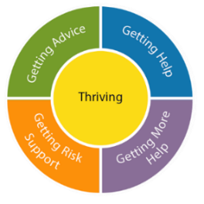
Appendix 1

ADHD Advice and Support Recommendations for Referrers

We hope to ensure that the correct support and intervention is identified for the child you are referring.

For ADHD referrals the following information is helpful in considering
whether a neurodevelopmental assessment or alternative support or advice would be more suitable. Prior to referral please consider the following (and provide all available info)
Hyperactivity, is the child… | …acting before thinking of consequences  …having difficulty maintaining attention for any period on a task  …jumping from one activity to another  …having difficulty with organizing themselves or their time  …tired due to poor sleep
Impulsivity, is the child… | …restlessness (inability to sit still, fidgeting, need to stand from seat)  …undertaking risky behaviours  …have a tendency to interrupt others’ conversations  …unable to wait own turn/ queue/ put hand up prior to calling out
Inattention, is the child… | …easily distracted  …observed day dreaming  …unable to complete work or tasks  …demonstrates difficulty with listening  …clumsy/ accident prone
Home Life (consider)  Who is at home  How is home life  Are you aware of any trauma or bad experiences |  | School Life(consider)  Is the child achieving well academically  Does the child have friends  Are there any bulling issues
Severity of Difficulties(consider)  Please provide evidence the impact on education/achievement/relationships/ daily functioning  Are there any identified risks or concerns |  | Frequency of Difficulties(consider)  Please define whether difficulties are apparent (and the same) in both school and home setting?  Time of Difficulties  When were difficulties first noted and what possible events may have surrounded this
If School Referring
School to demonstrate that they have observed the child for 10 weeks and recorded observations, including any changes and patterns in pupil’s behaviour?
Has the child got an EHCP? Or has the EHCP process commenced?
Has an Educational Psychologist Report been completed or requested?
All Referrers
Has the parent/ Guardian or child consented to a referral? [REQUIRED]
Has parent/carer been referred/completed a parent training programme?
Has Early Help been considered or referred to?
Have there been any recent significant events or changes the child's life, such as early adverse childhood experiences, death or family relationship difficulties?

